Alpha Beta Members Experience Zentangle
Alpha Beta Chapter of the Delta Kappa Gamma Society met via Zoom on February 7 to learn how to do zentangle and shape a valentine. The Zentangle Method is an easy-to-learn, relaxing, and fun way to create beautiful images by drawing structured patterns of dots, lines, and curves.

These patterns are called tangles. The presenters Mary Stayner and Sue Lyon who belong to other chapters in Illinois consider zentangle an artistic event along with being a key to relaxation. Zentangle can also be utilized in the classroom. Alpha Beta was joined by DKG members from other states who wanted to participate in zentangle.

At the business meeting Treasurer Janet Kilgus (Fairbury) shared a photo she received from the Marion Medical Mission that the 11th well that Alpha Beta purchased was installed on October 3, 2022, in the village of Chiwaba Nkhata, Malawi and it will serve 75 people. The well water not only provides safe drinking water but also the necessary knowledge, skills, and tools to manage and maintain the protected water source, so that safe drinking water continues in future years. Where wells have been built, waterborne diseases have been eliminated.

Louann Harms, Educational Excellence Chair, (Fairbury) reported that applications for the two chapter recruitment grants for high school girls who want to become teachers have been sent to area schools. The two grants have been increased to $300 each.

Pres. Marcia Wahls (Chenoa) reminded that the DKG State Convention will be held at the Double Tree by Hilton Hotel in Oak Brook on April 21-23. The information and application are available in the winter issue of the Newscaster and on the state web site.

The chapter will be participating in the Chapter Bazaar at the state convention. Various handcrafted items will be donated from some chapter members. Tickets will be sold and a buyer may place tickets in the bags by items she likes.

Pres. Wahls announced that the Creative Arts Retreat will be held on June 20-22 in a new area--the Double Tree by Hilton in Bloomington. Also, she said a few changes will be made in the chapter rules this spring.

The next meeting on March 18 will be held at the IEA building in Bloomington. Presenter Rebeca Bamboa, Illinois NEA Director, will discuss “Attacks on Books: Why Now? How to Respond!”

The Delta Kappa Gamma Society International (DKG) promotes professional and personal growth and excellence in education. The Society has chapters in 17 countries and provides grants for educational projects, scholarships, leadership training, mentoring, and global networking opportunities. For more information, visit www.dkg.org or contact Carol Hughes at chughes@mtco.com. 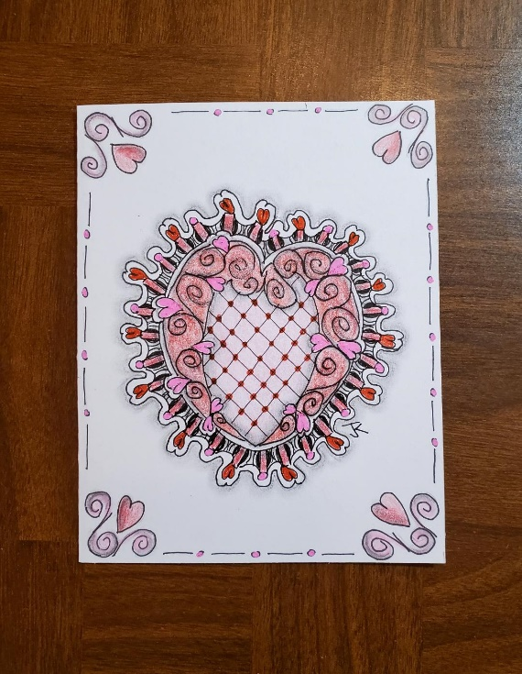
Photo: Using the Zentangle Method Janet Kilgus created this valentine.

