Principals Share Interview Tips with Educators Seeking a Teaching Position

Alpha Beta Chapter of the Delta Kappa Gamma Society met at the Eureka Christian Church on October 15. Retired Principal Rich Wherley, Eureka High School, and Principal Adam Hermann, El Paso-Gridley High School, shared a volume of tips in their program “How to Prepare for an Interview and What to Expect”.

First an applicant must send a resume via email that contains information that not only lists qualifications but especially appeals to the needs of the particular school. A principal may select some candidates to visit with the principal via Skype. So the applicant should be enthusiastic, explain why they want to teach at a particular school, share some other strengths they have like being able to teach history and physical education or coach some sport or direct plays.

A principal may choose 10 applicants and ask them to teach a ten-minute lesson via Skype or Zoom of their choice. Then the principal may choose all or some to come for a personal interview where the principal and a few teachers are present. At that time the candidate will be asked questions like “What do you hope to accomplish?” Responses should not be “canned” answers but specific examples.

Being a team player should be revealed in an applicant as a teacher not only works with other teachers but other staff members and administrators. A recommended book is The Ideal Team Player by Patrick Lencioni. Members also shared some interview suggestions.

Collegiate members were welcomed to the chapter which include Abby Boyle majoring in elementary education, Jordyn Fox majoring in elementary and special education, and Madison Draughan majoring in elementary and special education. Three former collegiate members were formally inducted as active members: Annie Friedrichsen, aide in special education at Glendale, East Peoria; Kammi Lamprecht, K-2 life skills at Armstrong, East Peoria, and Kendall Fulop, third grade at Low Point-Washburn.

At the business meeting Treasurer Janet Kilgus reported that the chapter has 38 active members and 6 collegiate members. Pres. Marcia Wahls explained grants for which collegiates and early career teachers may apply. Also, members may apply for state foundation grants twice a year to be used to benefit students. Music Chair Elaine Cunningham led the group in singing.

Pres. Wahls, Janet Kilgus, State Secretary; Lou Ann Jacobs, State Historian; and Carol Hughes, Past State President attended the Executive Board Meeting on Sept,16-17 in Bloomington. Work is being done for a new state website to make it easier to access and include more information. The Legislative Seminar will consist of three programs via Zoom on October 18-20.

Anne Marie Gump, noted English Language Learner Specialist from Williams Bay, Wisconsin will speak on “The Science of Reading: The Latest Reading Wars? Or Best Practices?”. The meeting will be held on Saturday, November 12th, in Fairbury at the White Community Room in the Dominy Memorial Library. ALL area educators are invited to attend.

The Delta Kappa Gamma Society International (DKG) promotes professional and personal growth and excellence in education. The Society has chapters in 17 countries and provides grants for educational projects, scholarships, leadership training, mentoring, and global networking opportunities. For more information, visit www.dkg.org or contact Carol Hughes at chughes@mtco.com.

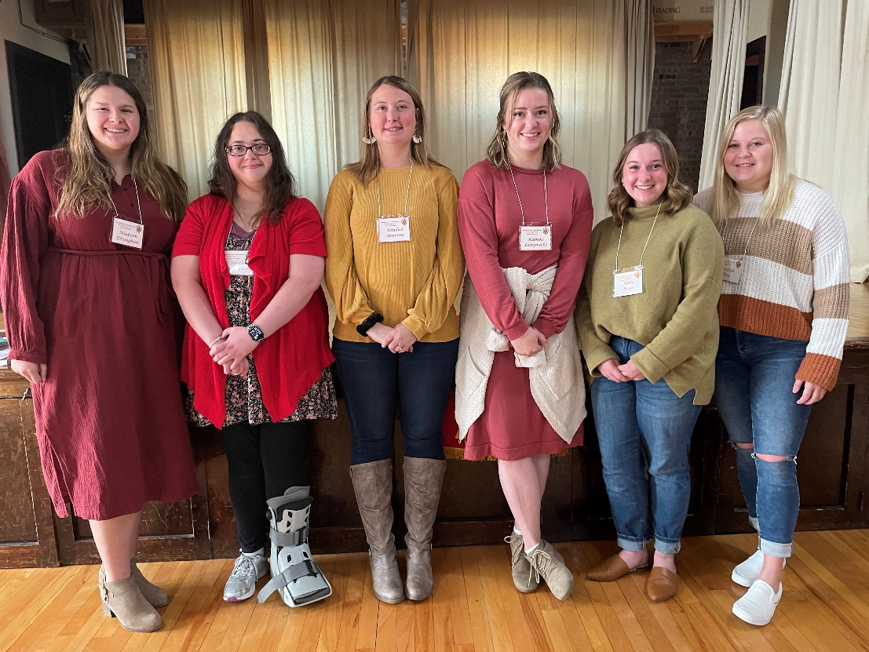

Photo: Madison Draughan, Annie Friedrichsen, Kendall Fulop, Kammi Lamprecht, Abby Boyle, and Jordyn Fox are recognized as they become DKG collegiate or active members inn Alpha Beta Chapter.

